**CS-2101L**

**Computer Organization and Assembly Language Lab**

**Examination System**

**Project Report By**

**Afaq Sabghatullah**

**Group Members:**

<<Afaq Sabghatullah >> <<Cs201008>>

<<Afaque Ahmed Shah>> << Cs201009>>

<<Aftab Ahmed>> << Cs201010>>

Table of Contents

1.Introduction 3

2.Scope 3

3.Flow Chart 3

4. Hardware/Software Requirements 3

4.1 Tools 3

4.2 Libraries , IDE 3

5. Screen Shots 3

6. Task Sheet 3

# Introduction:

Our project is based on concept of exams, where admin will collect data and perform several functions (insert, delete). Students and teachers will find out their examination / invigilation details.

# Scope:

Our project contains details and data of a complete examination system such that one can access and see its details prior to exam time and at the time of exam can easily reach out to its examination room / invigilation room be it a teacher or an student.

# Flow Chart:

|  |  |  |
| --- | --- | --- |
| Insert | Display Information | Delete Information |

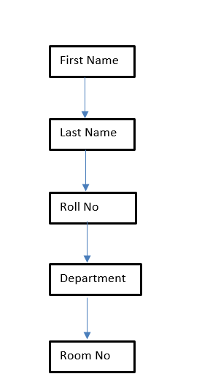

# 4. Hardware/Software Requirements

## 4.1 Mips

## 4.2 Mars

# 5. Screen Shots:

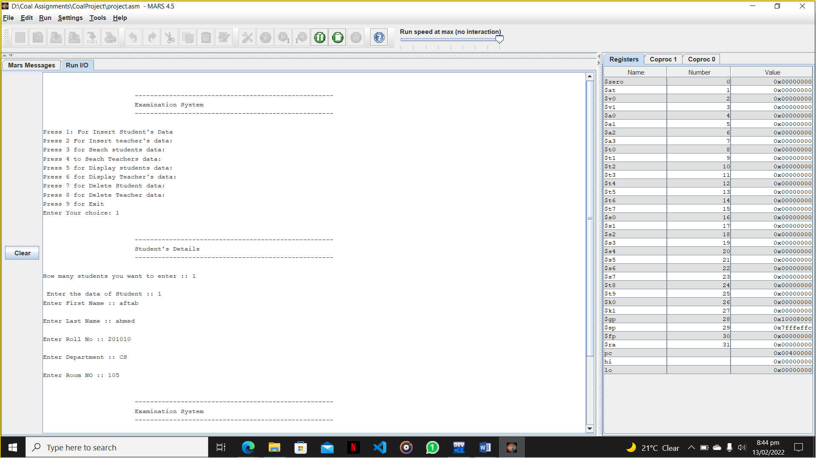

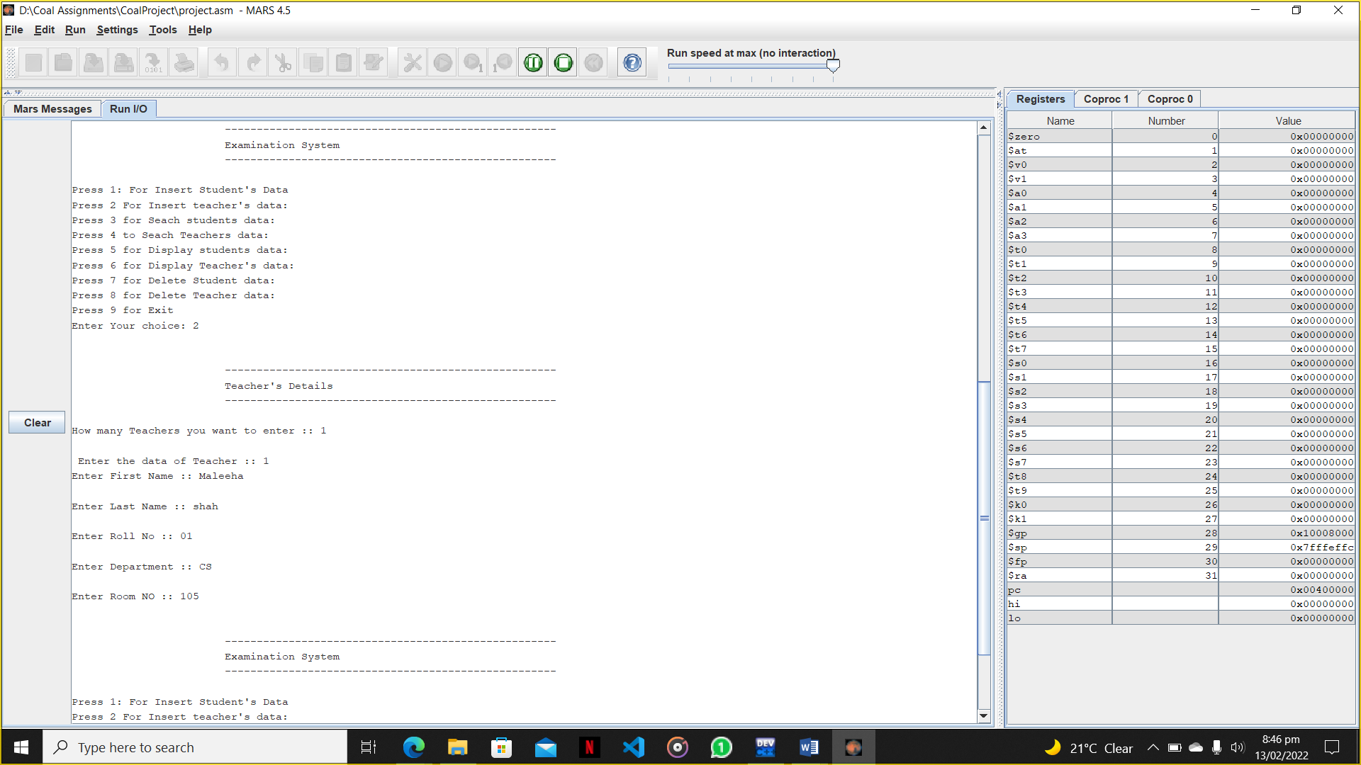

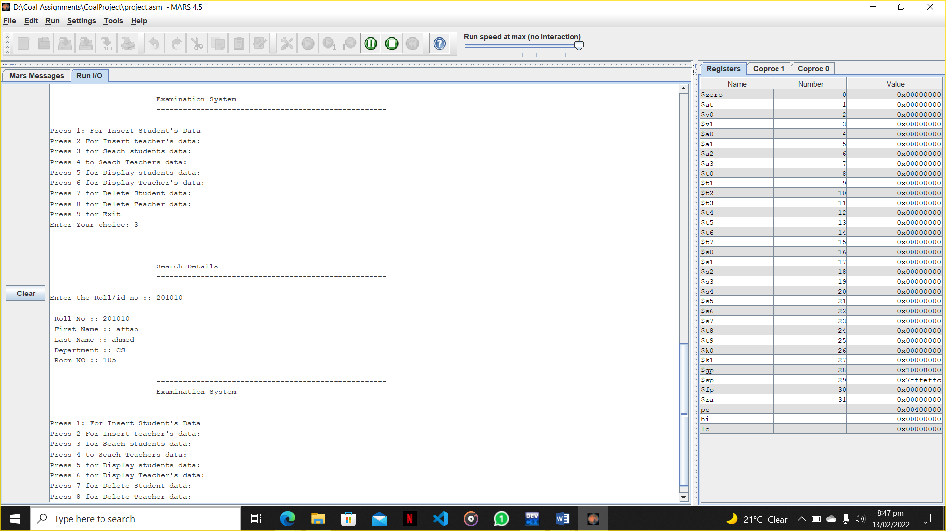

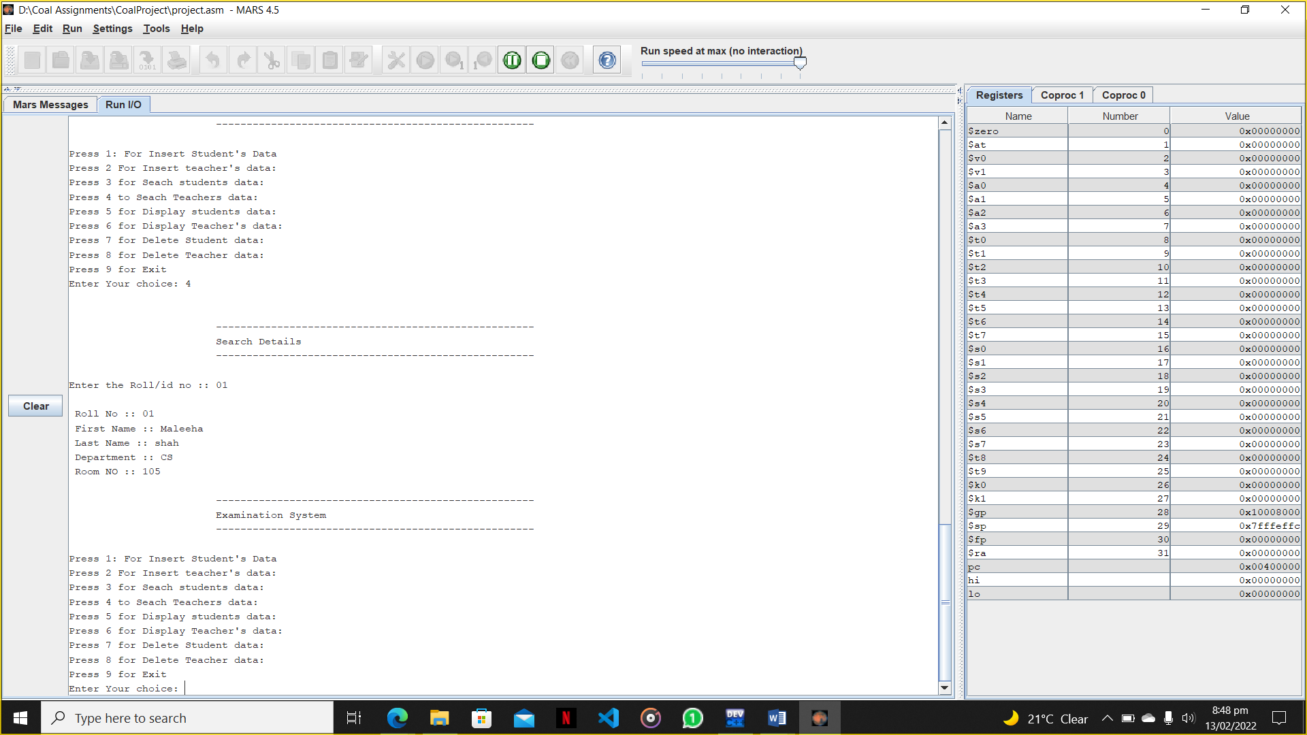

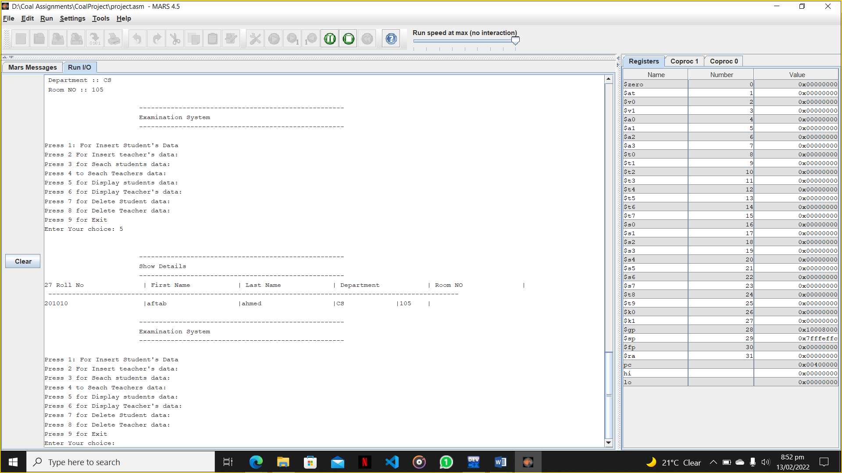

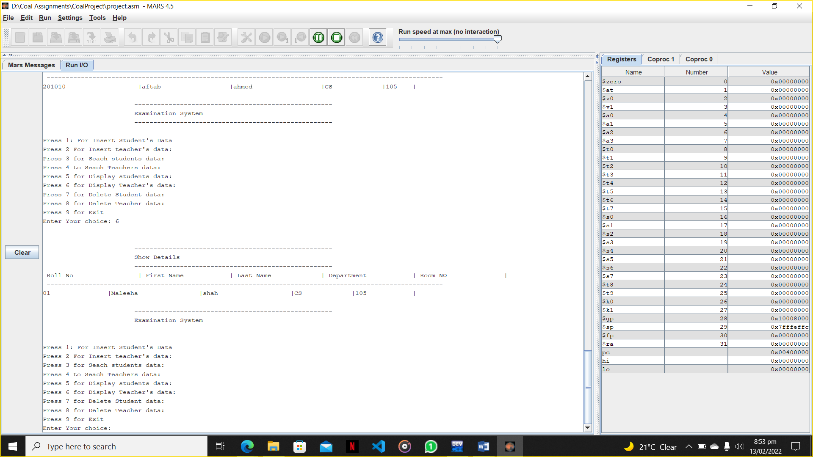

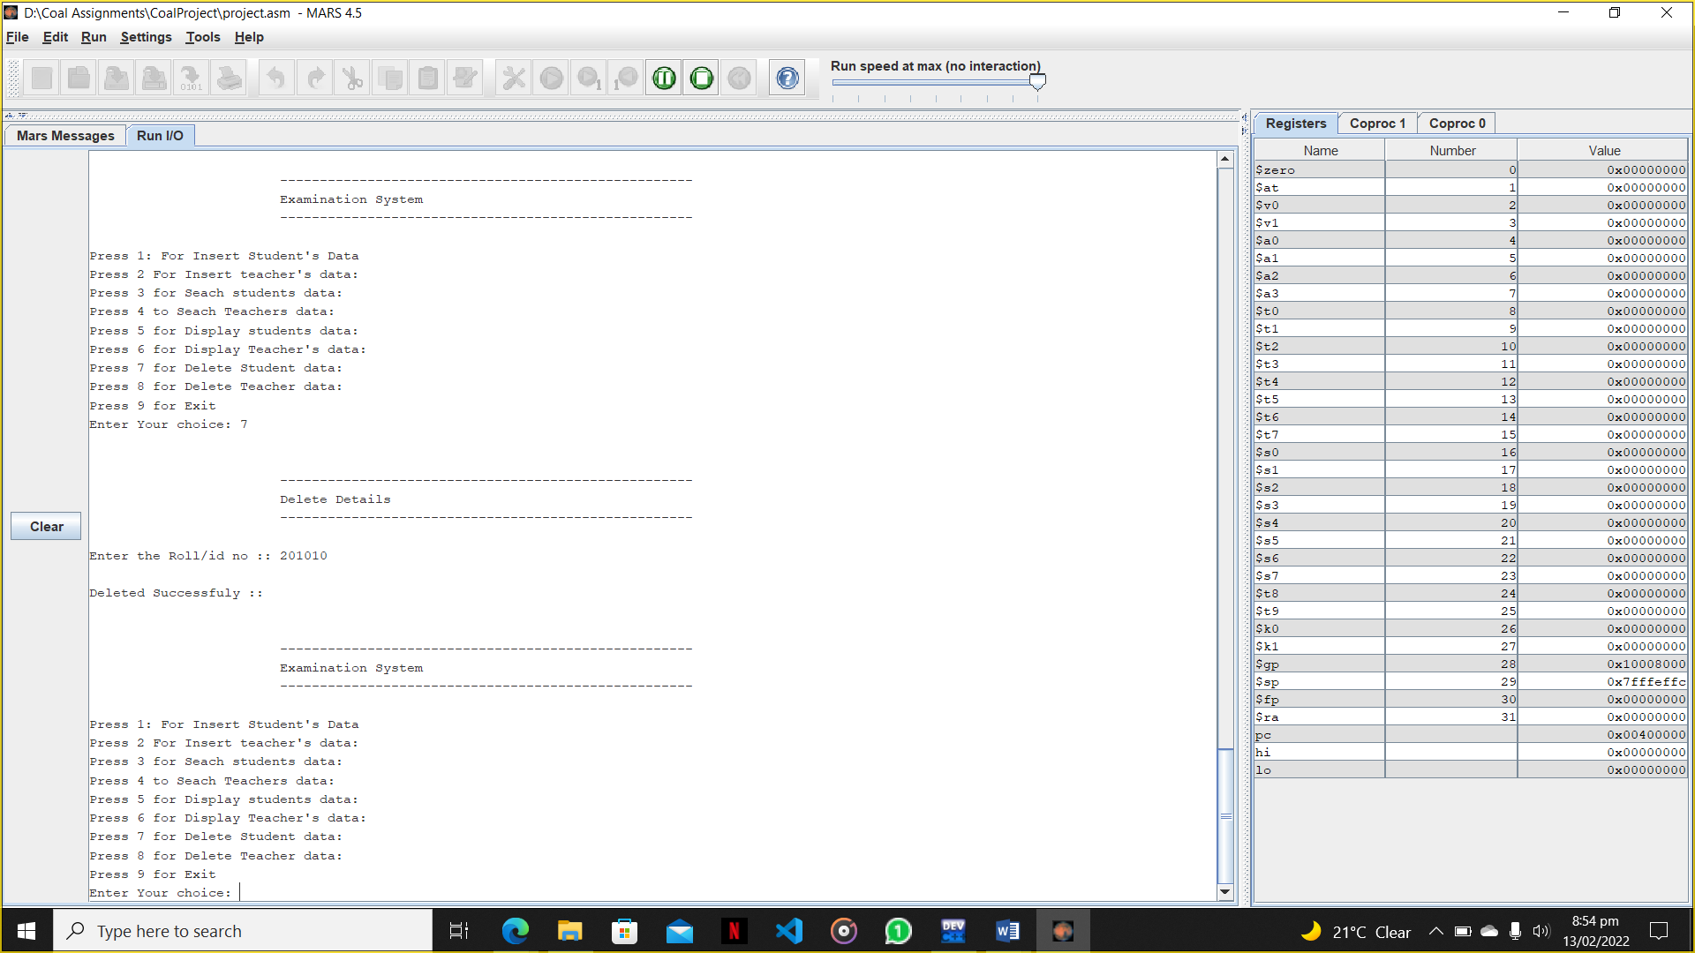

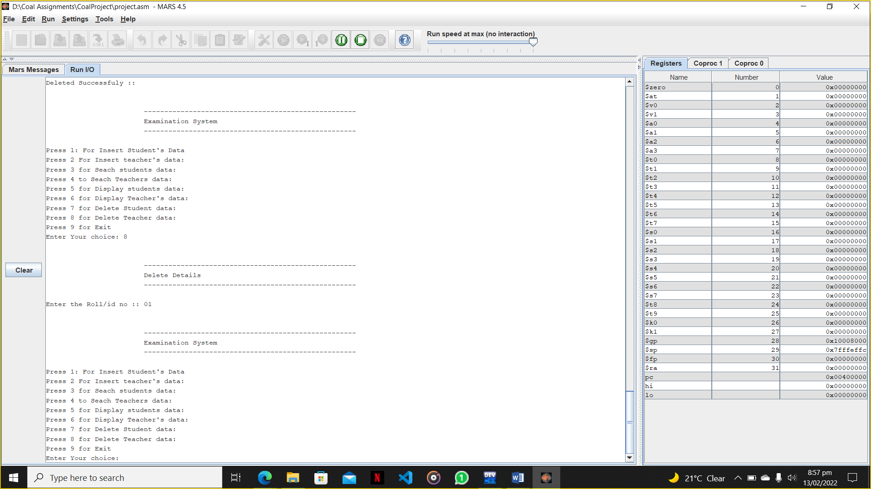

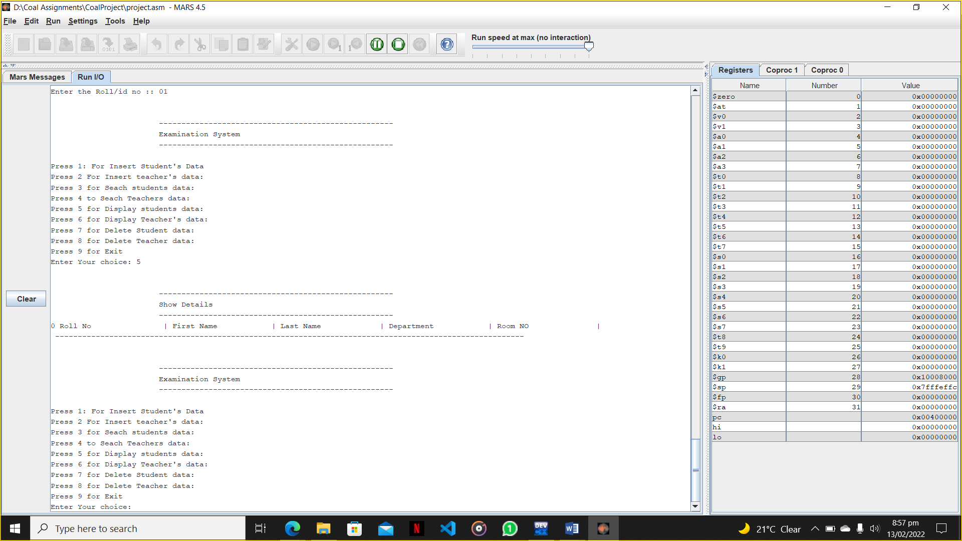

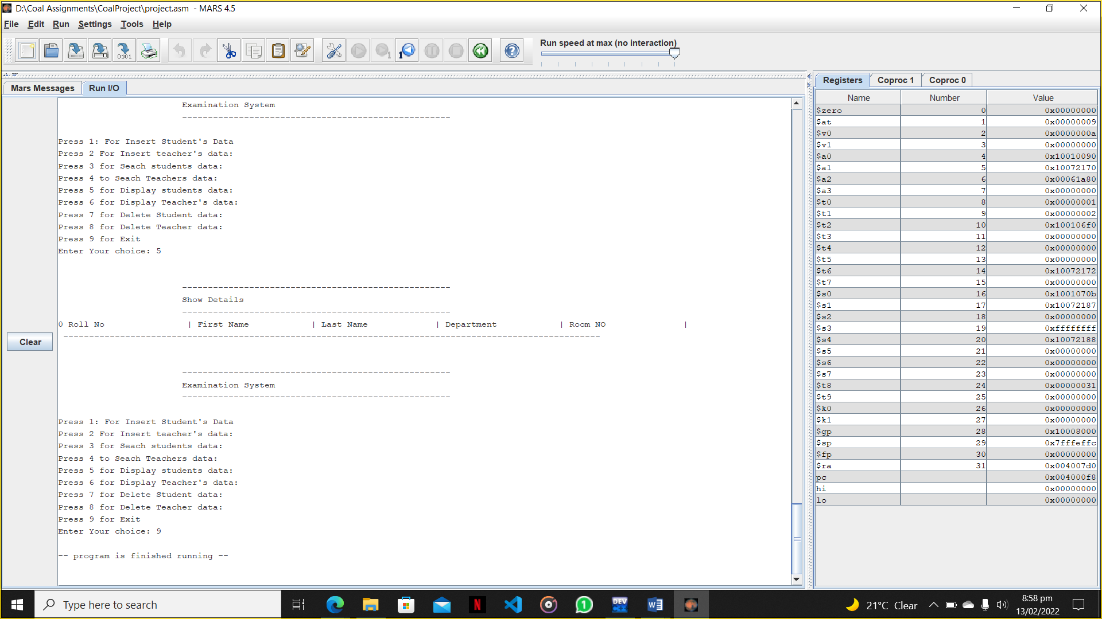

# 6. Code Screen Shots:

